ER DIAGRAM
WEB TECHNOLOGY

TOPIC Morya – Online Ganpati Idol Booking System

ER DIAGRAM
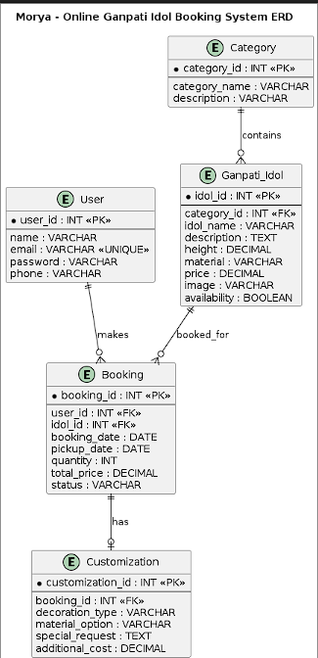

- User Microservice ERD
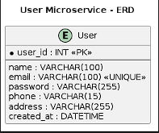

- Idol Microservice ERD
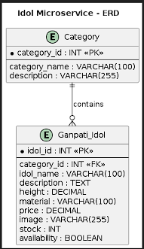
- Booking Microservice ERD
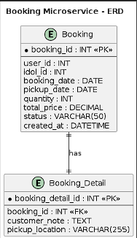

- Customization Microservice ERD
